Conservation Tips (Residential)
Conserving energy is the best way to lower your electricity bills. Here are some simple solutions to reducing your electricity bill and conserving energy:
Schedule Your Electricity Usage.
Use electricity when the price is lower to reduce costs. Most residential customers pay time-of-use rates for their electricity which means that rates are different depending on season and when you use your electricity. Time-of-Use pricing includes 3 rate periods: For more information please visit Ontario Energy Board – Managing Costs with Time-of-Use Rates
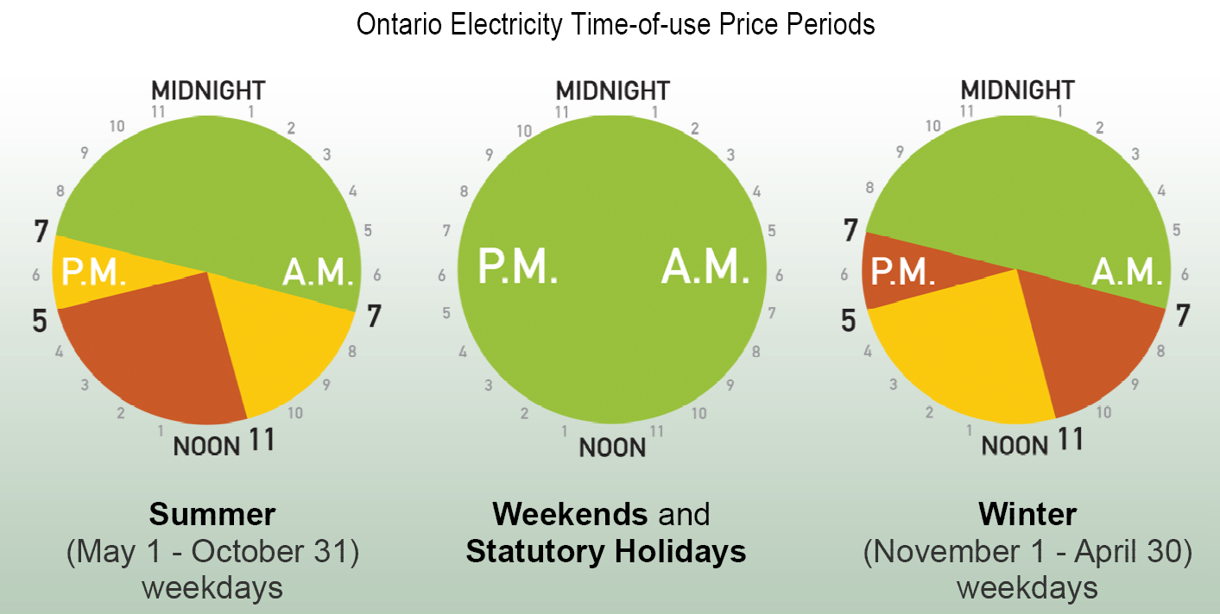
Source: Ontario Energy Board – Managing Costs with Time-of-Use Rates
Reduce Phantom Power
Plugged in appliances, lamps and other electronic devices continue to draw power even when they’re turned off. It is estimated that 10% of residential energy use is due to ‘phantom’ power, costing Canadians approximately $150/year.
To reduce phantom power consumption, unplug your electronic devices when not in use. Alternatively, you can purchase a power bar and switch it off.

Heating & Lighting
To improve energy efficiency within your house, make small changes to your heating and lighting.
- Switch to LED lightbulbs – LED bulbs are 75%-95% more efficient than incandescent light bulbs.

- Replace furnace filters every 3 months to improve airflow and reduce energy from running the furnace fan.
- Replace or install weather stripping or weather caulking around windows and doors. Wrap pipes and if necessary use window insulator kits for single-paned windows. Keeping heat inside the house reduces energy use.
For additional tips on energy conservation please visit - https://www.ontario.ca/page/how-use-less-electricity-home

